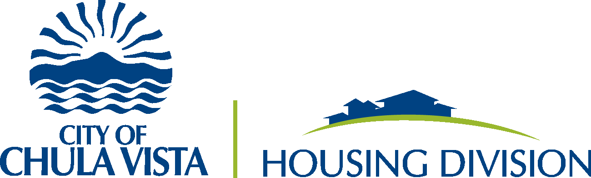

Citizen Participation Plan

2020-2024
24 CFR § 91.105

Attachment No. 1

Background Information
The Consolidated Plan is a U.S. Department of Housing and Urban Development (HUD) requirement for a city to receive federal housing and community development funding. Each Consolidated Plan must contain a strategy for citizen participation in the Consolidated Plan and Annual Action Plan process.

It is the policy of the City of Chula Vista to ensure adequate citizen involvement in the planning, implementation, and evaluation of its housing and community development programs. This document outlines the City’s plan for soliciting and receiving citizen input during preparation of the Five-Year Consolidated Plan covering the program years 2020-2024, and the individual Annual Action Plans during these same years. This Citizen Participation Plan (CPP) was drafted in accordance with Sections 91.100 and 91.105 of HUD’s Consolidated Plan regulations.

Administrative Responsibilities and Contact Information
The City of Chula Vista (City) is the recipient of all CDBG, HOME, and ESG funds. Specific program information is available at: http://www.chulavistaca.gov/departments/development-services/housing

The Development Services Housing Division has responsibility for administration of the Consolidated Plan process, which includes all activities related to development and dissemination of Consolidated Plans, Annual Action Plans, and Consolidated Annual Performance Evaluation Reports.

Encouraging Public Participation
It is the intent of the City of Chula Vista is to encourage and facilitate the participation of residents in the formulation of priorities, strategies and funding allocations related to the Consolidated Plan process, emphasizing involvement by low- and moderate-income persons, especially those living in low- and moderate-income neighborhoods. The City also encourages participation of minority populations, including people who do not speak English and persons with special needs. The City shall encourage the participation of residents of public and assisted housing developments, in the process of developing and implementing the Consolidated Plan. Finally, the City consults with the public and private agencies that provide housing, health and social services to City residents to identify the greatest needs of City residents, particularly low- to moderate-income residents and those with special needs.

Role of low/moderate-income people
The primary purpose of the programs covered by this CPP is to improve communities by providing decent housing, a suitable living environment, and growing economic opportunities—all principally for low- and moderate-income people. Because the amount of federal CDBG, HOME, and ESG money the City of Chula Vista receives and/or administers each year is primarily based on the severity of both poverty and substandard housing conditions in Chula Vista, the City recognizes the importance of public participation that genuinely involves people who have experienced these conditions.

It is the City’s intent to provide opportunities for meaningful involvement by low-income people at all stages of the process, including:

- Needs identification,
- Priority setting,
- Funding allocations, and
- Program recommendations.

Citizen Participation Goals FOR 2020-2024
The City of Chula Vista continually strives to improve participation processes so that all citizens are heard and included in community decisions. The residents of Chula Vista are diverse and should be met where they are, understanding the existence of various challenges and preferences. During this 5-year period, the City has set goals to expand participation methods and collect more valuable feedback. The following citizen participation methods will be implemented when possible:
- Take a defined period of time and attend community meetings that equally encompass all four districts within the city limits to gather public comments but also build trust and rapport with residents.
- Use online audience participation tools to collect feedback quickly, both at in-person and online meetings.

Stages of the Consolidated Plan Process
The policies and procedures in this CPP relate to five specific stages of action mentioned in law or regulation. These stages include:
- Stage 1. The needs assessment stage, i.e., the identification of housing and community development needs that generally occurs during development of a Consolidated Plan. For the 2020/2024 Consolidated Plan, this stage occurred from January through March of 2020.
- Stage 2. The plan development stage, i.e., preparation of a Draft Consolidated Plan and/or Draft Annual Action Plan. This occurred during February and March of 2020 for the Five-year Consolidated Plan and for the 2020/21 Action Plan.

- Stage 3. The approval stage, i.e., formal approval by elected officials of a final Consolidated Plan or Annual Action Plan. The timing of this stage depends on the meeting schedule of the City of Chula Vista, but generally occurs during March-April.

- Stage 4. The amendment stage, i.e., when a change is made in the proposed use of funds in an Annual Action Plan or to the priorities established in the Consolidated Plan, a formal Substantial Amendment will be proposed, considered and acted upon. (See “Stages in the Process” of this CPP for the definition of what constitutes a substantial amendment). This stage only occurs if a substantial amendment is required.

- Stage 5. The performance review phase, i.e., preparation of the CAPER. This occurs during August and September of each year.

Program Year in the City of Chula Vista
The “program year” established by the City for the use of these funds is July 1 through June 30.

Plan Year 1 (2020): July 1, 2020-June 30, 2021
Plan Year 2 (2021): July 1, 2021-June 30, 2022
Play Year 3 (2022): July 1, 2022-June 30, 2023
Play Year 4: (2023) July 1, 2023-June 30, 2024
Plan Year 5: (2024) July 1, 2024-June 30, 2025

Public Notice
This section describes how the City will issue public notices about the Five-year Consolidated Plan, Annual Action Plan, CAPER meetings, document draft review periods, amendments, and requests for release of HUD funds.

When notice will occur
The City will provide advanced public notice once any of the following documents are available for draft review and comment: the Proposed Annual Action Plan or Consolidated Plan, any proposed Substantial Amendment, the Annual Performance Report and Notices of Intent to Request Release of Funds. In addition, the City will provide public notice of all public hearings related to the funds or to the planning process covered by this CPP.

HUD considers two weeks advance public notice to be adequate for the public to permit informed comment. The amount of lead time can also vary, depending on the event. Specific minimum amounts of lead time for different events are described later in this CPP.

Forms of public notice
Public notices will be published in an English-language and Spanish-language general circulation publications. In addition, social media platforms such as Instagram, Twitter, Facebook and WhatsApp community groups will be utilized to encourage participation from the hardest to reach groups in our communities. Information regarding community involvement will also be posted on the Housing Division website: http://www.chulavistaca.gov/departments/development-services/housing. Whenever feasible, display ads and/or press releases for publication in appropriate neighborhood and ethnic newspapers will also be used. Copies of all public notices are available through the City’s website at: https://www.chulavistaca.gov/departments/development-services/planning/public-notices/public-notices. Notice will also be given through mailings to other organizations or individuals who have requested receipt of such notices. The proposed Consolidated Plan will be published to afford citizens, public agencies, and other interested parties a reasonable opportunity to examine its contents and to submit comments. The requirement for publishing will be met by publishing a summary of the proposed Consolidated Plan and proposed projects in the above-mentioned publications.

Public Access to Information
The City of Chula Vista will provide the public with reasonable and timely access to information and records relating to the data or content of the Consolidated Plan, as well as the proposed, actual, and past use of funds covered by this CPP. In addition, the City will provide the public with reasonable and timely access to local meetings related to the proposed or actual use of funds.

Standard documents
Standard documents to which public access will be provided include:
- Annual Action Plans (Proposed and Final);
- Consolidated Plans (Proposed and Final);
- Substantial Amendments to an Annual Action Plan or Consolidated Plan;
- Consolidated Annual Performance Reports; and,
- this Citizen Participation Plan.

Availability of standard documents
In the spirit of encouraging public participation, copies of standard documents will be provided to the public. These materials will be available in a form accessible to persons with disabilities, upon request by calling (619) 691-5047 or emailing: affhousing@chulavistaca.gov

Places where standard documents are available
Standard documents are available at the following location and website:

City of Chula Vista Development Services Housing Division
276 Fourth Avenue
Chula Vista, CA 91910;

City of Chula Vista Development Services Housing Website at: http://www.chulavistaca.gov/departments/development-services/housing

DISASTER OR EMERGENCY INSTANCES
In the event of a declared disaster or emergency, it may be necessary to revise public participation, noticing and public hearing procedures. Reasonable notification may be defined as 72 hours advance notice or less, depending upon the circumstances of the meeting; however, the City will strive to provide more than 72 hours advance notice of meetings, when practicable. When an in-person public hearing is not permitted due to social distancing or stay-at-home orders, virtual meetings may be held with reasonable notification and access for citizen participation. In addition, when hard copies are not available to due emergency closures of public facilities, online copies of documents will be made available for public review.
NOTE: If virtual hearings are used, real-time responses and accommodations for persons with disabilities and/or with limited English proficiency will be made available to the greatest extent possible. Refer to Public Hearing section for description of how the public may access virtual meetings and offer input.

Public Hearings
Public hearings will be held at key stages of the process to obtain the public’s views and to provide the public, to the greatest extent possible, with responses to their questions and comments. The City holds public hearings to obtain input regarding community needs during development of a Consolidated Plan, to review proposed uses of the funds in each Annual Action Plan, and to review program performance. More information about these specific hearings is contained in “Stages of the Process” of this CPP.

Access to public hearings
Public hearings will be held only after there has been adequate notice as described in “Public Notice” of this CPP. At a minimum, an advertisement in an English and Spanish language general circulation publication must be published no less than two weeks prior to the date of the public hearing is required. The City website at www.chulavistaca.gov also posts the City Council meeting agendas and information on each agenda item.

Public hearings are held before the City of Chula Vista Council Chambers; 276 Fourth Avenue Chula Vista, CA 91910—accessible by public transit.

Should the City face an emergency or crisis which would impede in-person public hearings, the public may still participate via teleconference, and watch the meeting online or on television.
To watch, members of the public can livestream at https://chulavista.legistar.com/Calendar.aspx, on AT&T U-verse channel 99 (throughout the County), and on Cox Cable channel 24 (only in Chula Vista). Recorded meetings are also aired on Wednesdays at 7 p.m. (both channels) and are archived on the City's website. Members of the public may also submit comments on the City’s online eComment portal at: https://chulavista.granicusideas.com/meetings.

Public hearings and populations with unique needs
All public hearings are held at a location accessible to people with disabilities. If non-English speaking or hearing-impaired residents request assistance to participate in a public hearing, the City will provide appropriate assistance to the greatest extent possible.

Public Meetings
The City holds public meetings related to the Consolidated Plan process in several areas in the City of Chula Vista (i.e. East, South and Northwest) in and around the month of September. Anyone interested in being notified of the meetings can call or otherwise contact the Development Services Housing Division to be placed on the community meeting mailing list.

Because the housing and community development needs of low- and moderate-income people are so great and so diverse, priorities must be set in order to decide which needs should get more attention and more resources than other needs. This is the basic reason the Consolidated Plan exists.

The City holds public meetings to obtain residents’ opinions about needs and what priority those needs have during the development stage of the Consolidated Plan (every 5 years). Public meetings about needs will be completed at least 30 days before a draft Consolidated Plan is published for comment, so that the needs identified can be considered by the City and addressed in the draft Plan.

Draft Annual Action Plan and/or Consolidated Plan
The law providing the funds related to this CPP calls for improved accountability of jurisdictions to the public. In that spirit and in compliance with the terms of the law, the City will use the following procedures:

General information
At the beginning of this stage, usually in November of each year, the City will provide public notice of the anticipated receipt of grant funds, including an estimate of the amount of CDBG, HOME, and ESG, funds it expects to receive in the following year and a description of the range of types of activities that can be funded with these resources. Also, the notice will provide an estimate of the amount of these funds that will be used in ways that will benefit low- and moderate-income people. Contact information will be included in the notice so that interested persons can obtain additional information.

Technical assistance
City staff will work with organizations representative of low- and moderate-income people who are interested in submitting a proposal to obtain funding for an activity. Technical assistance workshops regarding the funding process and how to apply will be provided to interested organizations early in the process.

Anti-Displacement
The City of Chula Vista strives to avoid or minimize the displacement of individuals as a result of HUD funded activities. Therefore, to the greatest extent feasible, the City:

- Considers the impact of displacement in site selection, during the project planning phase.
- Provides information to displaced individuals on available assistance and relocation benefits
- Reviews Anti-displacement Plans and Relocation Plans prior to funding.

Prior to approval of any HUD funded activity with the potential for temporary or permanent displacement of individuals, the responsible agency (City or private developer) provides a written plan of action for comparable replacement low-income housing and assistance to displaced persons, based on the Uniform Relocation Assistance and Real Property Acquisitions Polices Act of 1970 (URA), 49 CFR part 24).

Availability of a proposed plan
Copies of Proposed Consolidated Plans and/or Annual Action Plans are made available by request. In addition, copies are made available at the locations specified above in “Public Access to Information” of this CPP.

Public hearings and further action
In addition to the public meetings held in the community regarding proposed Plans, public hearings about proposed Plans are held by the City Council. All comments from the public meetings, as well as those received in writing during the 30-day public comment period, are presented to the Chula Vista City Council for their consideration. In the event that the City receives notification of one-time federal funds or grant opportunities, the City may use the suggested public comment period. All such comments are considered by staff and presented in the final Plans.

Final Annual Action Plan and/or Consolidated Plan
Copies of the final Plan and a summary will be made available to the public upon request at cost. In addition, copies will be available at the locations specified above in “Public Access to Information.”

Substantial Amendments to the Consolidated Plan and Action Plan
Occasionally, public comments warrant an amendment to the Consolidated Plan and/or Action Plan. The City will make documents available for interested parties of the draft Consolidated Plan and Annual Action Plan and Executive Summary for a comment period no less than 30-days. In the event that the City receives notification of one-time federal funds or grant opportunities, the City may use the suggested public comment period. The criteria for whether to amend a Consolidated Plan or Annual Action Plan is referred to by HUD as “Substantial Amendment Criteria.” The following are defined as substantial amendments by the City and will require public notice and provision of a public comment period:

- Over 50% of the original location of beneficiaries are impacted by the change;
- Contract scope of work of the proposed activity is modified to the point where it would generally be considered a new activity;

- Subrecipient assumes the responsibility of a project identified in the Action Plan;

- A new program or proposed activity is proposed for funding that was not previously identified in the Consolidated Plan and Action Plans;

- An administrative decision to reallocate funds to an activity in the Action Plan to other activities of equal or lesser priority need level, unless the decision is a result of:

- A federal government, state government, or local government declared state of emergency.

- A change in allocation priorities or a change in the method of distribution of funds;

- Any use of HUD 108 financing that was not described in the Consolidated Plan;

- Any changes in federal funding level after the Draft Consolidated Plan’s comment period has expired; and

- The resulting effect on the distribution of funds will not be considered an amendment or a substantial amendment.

Public notice and public hearing for substantial amendments
The City will provide reasonable notice of a proposed Substantial Amendment so that residents will have an opportunity to review and comment on it. Notice will be made according to the procedures described in “Public Notice” of this CPP and will allow a 30-day period for public comment. In the event that the City receives notification of one-time federal funds or grant opportunities, the City may use the suggested public comment period. In preparing a final Substantial Amendment, due consideration will be given to all comments and views expressed by the public. The final Substantial Amendment will have a section that presents all comments and explains why any comments were not accepted.

Disaster or Emergency Events that may Require Expedited Substantial Amendments and Public Participation It may be necessary to expedite substantial amendments in the event of a declared disaster or emergency. There are three types of disasters/emergency events that may necessitate an expedited substantial amendment, including: (1) man-made disasters, (2) natural disasters and (3) terrorism. Manmade disasters can include chemical spills, mass rioting, power outages, dam failure, plant explosions, etc. Natural disasters can include earthquakes, tsunamis, hurricanes, tornadoes, wild fires, flooding and public health issues, such as wide-spread disease like the 2019/2020 COVID-19 pandemic. Terrorism events include bomb threats, biochemical attacks (like the spread of anthrax) or cyber-attacks (like hacking, phishing, ransomware and virus distribution). These expedited substantial amendments may include funding new activities and/or the reprogramming of funds, including canceling activities to meet needs resulting from a declared disaster or emergency. Therefore, the City may use CDBG, HOME, and ESG funds to meet these needs with a 5-day public comment period instead of a 30-day public comment period, which is otherwise required for substantial amendments. For activities related to FY 2020, FY 2021 and the CARES Act, the City may provide a 5-day public comment period for substantial amendments beginning April 11, 2020, as permitted under a HUD waiver.

Consolidated Annual Performance Evaluation Report (CAPER)
Every year, the City must submit to HUD the Consolidated Annual Performance Evaluation Report (CAPER), within 90 days of the close of the program year, i.e., by September 28. In general, the CAPER describes how funds were actually spent and the extent to which these funds were used for activities that benefited low- and moderate-income people.

Public notice for CAPERs
The City will provide reasonable notice that the CAPER is available so that residents will have an opportunity to review and comment on it. Notice will be made according to the procedures described in “Public Notice” above. Public comments will be accepted during a 15-day comment period described in the public notice.

Copies of the CAPER will be made available to the public upon request. In addition, copies will be available at the locations listed in “Public Access to Information.”

In preparing a CAPER for submission to HUD, consideration will be given to all comments and views expressed by the public, orally or submitted in writing. The CAPER sent to HUD will have a section that presents all comments.

Notice of Intent to Request Release of Funds (NOI/RROF)
This notice is to be published when an Environmental Review Record (ERR) is complete and has been signed by the preparer and the certifying officer. The notice must specify, at a minimum, an additional 15-calendar day period within which persons may object to the use release of funds.

Complaint Procedures
Written complaints from the public about the City’s citizen participation process or the Consolidated Plan process will receive careful consideration and will be answered in writing within 15 working days. Written complaints should be sent to the CDBG Coordinator at the following address: City of Chula Vista Development Services Housing Division, 276 Fourth Avenue Chula Vista, CA 91910

Amending the Citizen Participation Plan
This Citizen Participation Plan can be amended only after the public has been notified of the City’s intent to modify it and only after the public has had a reasonable chance to review and comment on proposed substantial changes.

APPENDIX A

Low/Moderate-Income Areas
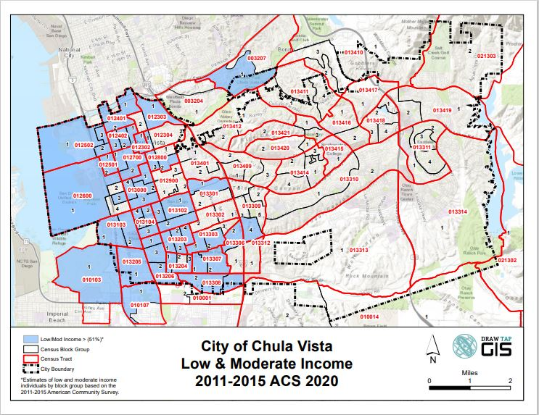

APPENDIX B

Grant Descriptions

Community Development Block Grant (CDBG): CFDA - 14.218
HOME Investment Partnership: CFDA – 14.239
Emergency Solutions Grant (ESG) Programs: CFDA – 14.231

The City of Chula Vista Housing Division provides U.S. Department of Housing and Urban Development (HUD), Community Development Block Grant (CDBG), HOME Investment Partnership Act, and Emergency Solutions Grant (ESG) funding to promote public serviced, capital improvement projects, economic development activities (subject to HUD approval) and production of affordable housing activities that benefit low-and moderate income persons living in Chula Vista.

Please refer to the Notice of Funding Availability for a description of each of the funding sources and programmatic requirements.

A brief description of each program is described below, and funding is subject to the priorities listed in the Consolidated Plan and Notice of Funding Availability.

COMMUNITY DEVELOPMENT BLOCK GRANT (CDBG)
The Community Development Block Grant (CDBG) Program is administered by HUD and is authorized under Title 1 of the Housing and Community Development Act of 1974, as amended. The purpose of the CDBG Program is to enhance and maintain viable urban communities through the provision of decent housing, a suitable living environment, and the expansion of economic opportunities, principally for low -and moderate-income persons. Not less than 70 percent of CDBG funds must be used for activities that benefit low- and moderate-income persons. In addition, each activity must meet one of the following national objectives for the program: benefit low- and moderate-income persons, prevention or elimination of slums or blight, or address community development needs having a particular urgency because existing conditions pose a serious and immediate threat to the health or welfare of the community for which other funding is not available.

HOME INVESTMENT PARTNERSHIP PROGRAM (HOME)
The Home Investment Partnerships (HOME) Program as authorized by the 1990 National Affordable Housing Act, as amended by the Housing and Community Development Act of 1992. The intent of the HOME Program is to expand the supply of decent, safe, sanitary and affordable housing. This is done through the following:
- Community Housing Development Organizations (CHDO). Home ownership assistance
- Rehabilitation
- New construction of affordable housing
- Tenant-based rental assistance
- Acquisition of property for affordable housing
- Administration

In order for an activity or program to be eligible for HOME funding, it must qualify by meeting the following guidelines:

- 100% of all funding must be used to benefit households or persons with incomes less than 60% of the area median income.
- All HOME-funded projects must have 25% non-federal matching funds.
- The HOME program has strict long-term affordability requirements which differ based on the type of project and the amount of funding requested per unit.
- Prevailing wage requirements are different from the CDBG program. Federal prevailing wages (Davis-Bacon) are triggered when there are 8 or more units assisted with CDBG funds. For the HOME program, it is 12 or more units.

Emergency Solutions Grant (ESG)

The ESG program provides funding to:
- Engage homeless individuals and families living on the street;
- Improve the number and quality of emergency shelters for homeless individuals and families;
- Help operate these shelters;
- Provide essential services to shelter residents,
- Rapidly re-house homeless individuals and families, and,
- Prevent families/individuals from becoming homeless.

For specific requirements and eligible costs, see 24 CFR 576

APPENDIX C

Flow Chart
Submittal of Annual Action Plan

